



S.K.P ENGINEERING COLLEGE

Approved by AICTE & Affiliated to Anna University

NH 66, Somasipadi Post,Chinnakangiyanur, Tiruvannamalai,

Tamil Nadu-606611

**DEPARTMENT OF COMPUTER SCIENCE AND**

**ENGINEERING**

BACHELOR OF ENGINEERING 2024-2025

FIFTH SEMESTER

**PROJECT TITLE: TO SUPPLY LEFTOVER FOOD TO POOR**

**Project Created by:** Dinesh. P, Durga Devi. E, Elumalai. A, Geetha. P

**Project Reviewed by: Nasrudeen sha** (AP/CSE)

**College Code:** 5122

**Team ID** : NM2024TMID18358





 S.K.P ENGINEERING COLLEGE

Approved by AICTE & Affiliated to Anna University

**DEPARTMENT OF COMPUTER SCIENCE AND**

**ENGINEERING**

Certified that this is a bonafide record of work done by

Name : Dinesh. P, Durga Devi. E, Elumalai. A, Geetha. P

University Reg No : 512222104017,18,19,20

Year / Semester : 3 / 5

Branch : CSE

Year : 2024-2025

## Staff-in-Charge Head of the Department

Submitted for the Practical Examination held on

**Internal Examiner External Examiner**





**TO SUPPLY LEFTOVER FOOD TO POOR**

#### PROJECT VIEW:

This project is focused on to supply leftover food to poor, designed to address the challenges of food wastage and hunger. The goal is to deliver a comprehensive solution by leveraging Salesforce CRM and a mobile application to streamline food collection and distribution processes. Through this project, we aim to enhance operational efficiency, user experience, and data accuracy and support the long-term goals of reducing food insecurity and promoting sustainability.

# OBJECTIVES:

**Increase Community Engagement:** Engage at least 50 local businesses, volunteers, and organizations in food donation activities within the first year.

**Reduce Food Wastage**: Decrease food wastage in partnered businesses by 30% in the first six months.

**Improve Operational Efficiency**: Achieve a 20% reduction in the time taken to collect and distribute food within the first year.

**Reduce Food Wastage:** Minimize food wastage by efficiently collecting leftover food from donors and redistributing it to those in need.

**Address Hunger and Food Insecurity:** Provide an organized and sustainable approach to combat hunger and improve access to nutritious food for underprivileged communities.





**Streamline Food Collection and Distribution:** Utilize Salesforce CRM and a mobile application to automate and optimize the process of food collection, tracking, and distribution.

**Enhance Operational Efficiency:** mprove the effectiveness of food redistribution operations by leveraging technology to manage resources, logistics, and communications.

**Improve User Experience:** Develop a user-friendly interface for donors, volunteers, and recipients to participate seamlessly in the food redistribution process.

**Promote Sustainability:** Foster a sustainable ecosystem by aligning efforts with the

principles of reducing food wastage.

**Support Long-term Goals:** Contribute to long-term societal goals by raising awareness

about food wastage and creating a scalable model for addressing food insecurity

globally.

**Specific Outcomes**

**Food Collection and Distribution**

* + **Key Deliverable**: Establish a robust food collection network.
  + **Outcome**: Successfully collect and distribute 10,000 meals per month to underprivileged communities.

**User Engagement**

**Key Deliverable**: Launch and maintain a user-friendly mobile app for donors and volunteers.



 **Outcome**: Achieve 5,000 app downloads and 2,500 active users within the first year .

**Data Management**

**Key Deliverable**: Implement a Salesforce CRM system to manage food donations and distributions.

**Outcome**: Ensure 95% data accuracy in tracking food donation and distribution activities.

**Training and Awareness**

**Key Deliverable**: Conduct training sessions and awareness campaigns.

**Outcome**: Train 1,000 volunteers and raise awareness among 10,000 community members within the first year.

These goals and outcomes will guide the project towards its mission of reducing food wastage and hunger while promoting community engagement and sustainability.

**SALESFORCE KEY FEATURES AND CONCEPTS UTILIZED**

#### ****Salesforce CRM****

* **Centralized Data Management**: A unified platform to track and manage food donations, inventories, distribution schedules, and donor interactions in real-time.
* **Customer Relationship Management**: Enhances communication and collaboration with donors, volunteers, and beneficiaries, ensuring strong and lasting relationships.

#### 2. ****Mobile Integration****

* **Mobile App for Donors and Volunteers**: A user-friendly interface for logging donations, assigning volunteers to tasks, and monitoring the pickup and distribution processes.
* **Real-Time Updates**: Push notifications to keep stakeholders informed about food collection schedules, updates on delivery status, and emergencies.



#### 3. ****Automation****

* **Workflow Automation**: Automates repetitive and time-consuming tasks, such as notifying volunteers about new assignments, updating donors about the impact of their contributions, and generating acknowledgment emails.
* **Approval Processes**: Implements automated approval mechanisms for critical tasks such as initiating large-scale food distribution or allocating resources to specific areas.

#### 4. ****Data Analytics and Reporting****

* **Embedded Analytics**: Leverages Einstein Analytics to provide predictive insights, such as identifying high-need areas or forecasting food demand trends.
* **Customizable Reports and Dashboards**: Enables monitoring of donation trends, distribution timelines, community outreach efforts, and impact measurements with visual and interactive tools.

#### 5. ****Community Cloud****

* **Engagement Portals**: A dedicated space where donors, NGOs, volunteers, and beneficiaries can connect, share updates, and collaborate.
* **Feedback Mechanisms**: Easy-to-use feedback tools to collect insights and suggestions from beneficiaries and improve service quality. 

#### 6. ****Security and Compliance****

* **Data Security**: Implements field-level security, role-based access controls, and data encryption to protect sensitive information such as donor details and beneficiary identities.

**Regulatory Compliance**: Ensures adherence to food safety and distribution laws, as well as GDPR and other data protection standards.

 7. **Integration Capabilities**

* **API Integrations**: Facilitates seamless connections with external systems like NGO management tools, food quality inspection platforms, and logistics software.
* **Third-Party App Integration**: Incorporates advanced functionalities such as geolocation mapping for food pickup routes, real-time inventory tracking, and temperature monitoring for perishable food items.

#### 8. ****Einstein AI and Machine Learning****

* **Predictive Analysis**: Uses AI to predict food demand, identify high-donation potential donors, and optimize logistics for efficient distribution.
* **Intelligent Recommendations**: Suggests the best routes for food delivery and identifies high-need areas based on historical data.

#### 9. ****Salesforce Flow****

* **Flow Builder**: Creates automated, guided workflows for volunteers, such as step-by-step processes for food collection or instructions for handling donations.
* **Orchestration**: Orchestrates complex, multi-step operations like coordinating food pickups from multiple donors and scheduling deliveries to beneficiaries.

#### 10. ****Marketing Cloud****

* **Email and Social Campaigns**: Engages donors and volunteers through personalized emails, social media posts, and campaigns highlighting success stories and urgent needs.
* **Impact Awareness**: Uses targeted campaigns to educate the public on food wastage and the impact of their contributions.



#### 



#### 11. ****Salesforce Maps****

* **Route Optimization**: Optimizes pickup and delivery routes for food collection, minimizing transportation costs and time.

**Geospatial Insights**: Visualizes donor locations, food banks, and beneficiary areas for better planning and resource allocation. GDPR and other data protection standards.

#### 12. ****Service Cloud****

* **Case Management**: Tracks issues or requests raised by donors, volunteers, or beneficiaries, ensuring prompt resolution.
* **Knowledge Base**: Provides a centralized repository of information, such as food safety guidelines, volunteer FAQs, and donor instructions.

#### 13. ****Chatter for Collaboration****

* **Real-Time Communication**: Facilitates collaboration among team members, donors, and volunteers with chat features, updates, and notifications.
* **Activity Feeds**: Shares real-time updates about food collections, delivery progress, and event highlights.

#### 14. ****AppExchange Solutions****

* Access to pre-built applications for logistics, donor management, inventory tracking, and volunteer coordination to enhance functionality and reduce development time.

# 

# 

# DETAILED STEPS TO SOLUTION DESIGN

#### ****1.Define Requirements and Objectives****

* **Requirement Gathering**: Collaborate with stakeholders to identify system requirements, including features, functionalities, and key performance indicators (KPIs).
* **Objective Alignment**: Ensure all design elements align with the project's objectives of reducing food wastage, improving efficiency, and addressing hunger.

#### 2. ****Data Model Design****

* **Entities and Relationships**:
  + **Donor Model**: Includes fields for contact details, donation history, preferences, and location for scheduling pickups.
  + **Volunteer Model**: Tracks availability, assigned tasks, roles, and feedback on tasks performed.
  + **Beneficiary Model**: Captures demographics, food requirements, and location for delivery.
  + **Food Donation Model**: Stores details of donated items, including type, quantity, expiration dates, and pickup or drop-off status.
  + **Distribution Schedule Model**: Manages logistics, including pickup times, delivery routes, and timelines.



#### 3. ****User Interface Design****

* **Donor Interface**:
  + Donation submission form with pre-filled fields for regular donors.
  + Notifications about scheduled pickups and impact reports.
  + Real-time tracking of food donation status.



* **Volunteer Interface**:
  + Task dashboard with clear task assignments, schedules, and a feedback mechanism.
  + Options to report issues or emergencies in real-time.
* **Beneficiary Interface**:
  + Request submission system with fields for quantity and type of food needed.
  + Feedback form for received assistance.
* **Admin Interface**:
  + Comprehensive dashboards for tracking and managing donor, volunteer, and beneficiary activities.
  + Reporting tools for analyzing impact metrics and operational efficiency.

#### 4. ****Business Logic Implementation****

* **Workflow Automation**:
  + Automate notifications for donation pickup reminders, volunteer task assignments, and food delivery updates.
  + Generate reports on food wastage reduction, beneficiary satisfaction, and volunteer efficiency.
* **Approval Processes**:
  + Define criteria for approving large donations, critical delivery schedules, and other sensitive operations.
  + Automate approval workflows to streamline operations.
* **Event-Driven Processes**:
  + Trigger specific actions based on events, such as sending alerts when a donation is logged or inventory levels are low.



#### 5. ****Integration with Third-Party Applications****

* **Mapping Integration**:
  + Integrate with geolocation services (e.g., Google Maps) to optimize pickup and delivery routes.
  + Enable real-time location tracking for logistics.
* **Inventory Management**:
  + Connect with tools to monitor inventory levels and prevent overstocking or wastage.
  + Automate reallocation of food nearing expiration. 
* **Communication Tools**:
  + Integrate SMS and email services for seamless communication with donors, volunteers, and beneficiaries.

#### 6. ****Analytics and Reporting****

* **Data Collection and Storage**:
  + Use Salesforce CRM to store historical data for donations, distributions, and feedback.
* **Insights Generation**:
  + Implement Einstein Analytics for predictive insights, such as identifying high-donation periods or areas of high need.
  + Develop dashboards to visualize key metrics like food wastage reduction, donor engagement, and volunteer performance.
* **Custom Reports**:
  + Provide stakeholders with tailored reports highlighting project progress and areas for improvement.

#### 7. ****Security and Compliance****



* **Access Control**: Implement role-based access to ensure that only authorized users can view or edit sensitive information.
* **Data Encryption**: Encrypt data at rest and in transit to protect donor, volunteer, and beneficiary information.
* **Regulatory Adherence**: Ensure compliance with local food safety and data protection regulations, such as GDPR or HIPAA.

#### 8. ****Testing and Quality Assurance****

* **Unit Testing**: Validate individual components such as forms, workflows, and reports.
* **Integration Testing**: Ensure seamless functionality between Salesforce CRM, mobile applications, and third-party tools.
* **User Acceptance Testing (UAT)**: Conduct UAT with stakeholders to gather feedback and refine the solution.
* **Performance Testing**: Test system scalability and response time under high transaction volumes.

#### 9. ****Deployment and Training****

* **Deployment Plan**: Gradual rollout of the system, starting with a pilot project to ensure stability.
* **User Training**: Provide detailed training sessions and user guides for donors, volunteers, beneficiaries, and administrators. 
* **Support Setup**: Establish a dedicated support team to handle user queries and system issues post-deployment.

#### 10. ****Continuous Improvement****

* **Feedback Loop**: Regularly collect feedback from all stakeholders to identify areas of improvement.
* **Feature Enhancements**: Implement updates based on emerging needs, such as new donation tracking features or advanced analytics.
* **Monitoring and Maintenance**: Use Salesforce monitoring tools to track system performance and address issues proactively.

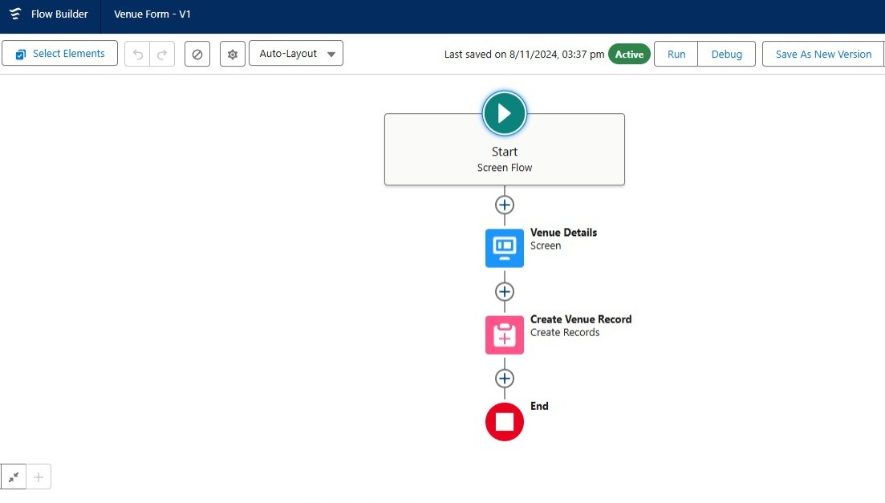

# 



# TESTING AND VALIDATION

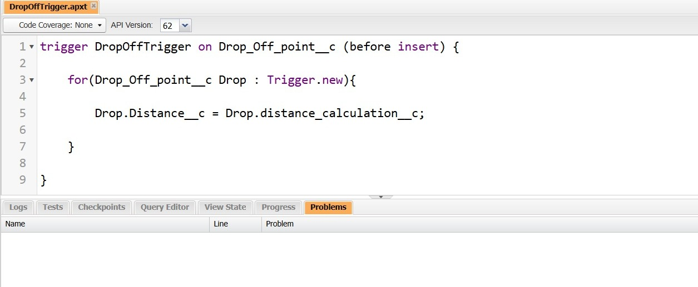

**1. Integration Testing**

* **Third-Party Integration Validation**: Test all integrations with external systems (e.g., mapping services, logistics platforms, and inventory management tools) to ensure smooth data exchange and functionality.
* **API Testing**: Validate the correctness, reliability, and performance of APIs used for communication between the Salesforce backend and the mobile app.
* **End-to-End Testing**: Simulate real-world workflows (e.g., a donor logs a donation, volunteers pick it up, and beneficiaries receive it) to ensure all system components work together as intended.

**2. Data Validation and Integrity Testing**

* **Data Accuracy**: Verify that data entered by users (donors, volunteers, and beneficiaries) is stored accurately in the database.
* **Data Duplication**: Test mechanisms to prevent duplicate entries, such as repeated donation logs or overlapping schedules.
* **Data Consistency**: Ensure that updates to records (e.g., changes in donor details or distribution schedules) reflect accurately across all system components.



**3. Security Testing**

* **Authentication and Authorization**: Test role-based access controls to ensure only authorized users can access sensitive information and functionalities.
* **Data Encryption**: Validate that sensitive data (e.g., donor details, beneficiary information) is encrypted both in transit and at rest.
* **Vulnerability Testing**: Perform security scans to identify vulnerabilities such as SQL injection, cross-site scripting (XSS), and cross-site request forgery (CSRF).
* **Penetration Testing**: Simulate cyberattacks to evaluate the system's security posture and identify potential weaknesses.

**4. Load and Stress Testing**

* **Scalability Testing**: Evaluate system performance under increased loads, such as multiple concurrent users logging donations or accessing schedules.
* **Stress Testing**: Test the system's behavior under extreme conditions, such as a high influx of donations during a disaster.
* **Resource Utilization**: Monitor CPU, memory, and database performance during load testing to identify bottlenecks.

**5. Backup and Disaster Recovery Testing**

* **Backup Validation**: Ensure backups are created at regular intervals and can be restored successfully.
* **Failover Testing**: Test the system's ability to switch to a backup server or database in case of hardware or software failure.

**6. Mobile App Testing**

**Offline Functionality**: Verify that mobile app users (e.g., donors and volunteers) can perform critical functions offline and sync data when back online.



*  **Push Notifications**: Test the reliability and timing of notifications for updates such as scheduled pickups and volunteer tasks.
* **Battery and Resource Usage**: Assess the app's impact on device battery life and resource usage to ensure efficiency.

**7. Data Migration Testing**

* **Historical Data Accuracy**: If migrating existing data (e.g., previous donations or schedules), ensure data is migrated correctly without loss or corruption.
* **Mapping and Transformation**: Verify that data from legacy systems maps correctly to new system fields and formats.

**8. Localization and Internationalization Testing**

* **Language Support**: Ensure the UI and notifications are available in multiple languages if targeting diverse user groups.
* **Regional Settings**: Validate date, time, currency, and number formats for different regions if applicable.

**9. Scenarios-Based Testing**

* **Edge Cases**: Test edge scenarios, such as a single donor contributing multiple donations simultaneously or a beneficiary requesting food at an unusual location.
* **Negative Testing**: Intentionally input invalid data (e.g., incomplete forms, unsupported formats) to ensure the system handles errors gracefully.



 **10. Continuous Testing**

* **CI/CD Integration**: Automate testing as part of the Continuous Integration/Continuous Deployment (CI/CD) pipeline to identify issues early in the development cycle.
* **Regression Suite Automation**: Build automated regression test suites to quickly validate system stability after updates or feature additions.

**11. Real-Time Monitoring and Feedback**

* **Error Logs**: Set up real-time error logging to identify and address issues promptly.
* **User Feedback Loop**: Implement mechanisms to capture user feedback during testing phases and use it to refine the system.

## KEY SCENARIOS ADDRESSED BY SALESFORCE IN THE IMPLEMENTATION PROJECT

#### ****1. Food Donation Logging****

**Scenario**: Donors need a streamlined, intuitive process for logging food donations efficiently.

**Salesforce Solution**:  
Salesforce offers customizable objects and forms that can be seamlessly integrated into a user-friendly mobile app or web portal. Donors can log their food donations in real time, enabling better tracking and management of inventory.

* **Custom Forms**: These forms are tailored to capture all essential details such as food type, quantity, pickup location, and expiry date.
* **Integration with Inventory Management**: The logged donations are immediately updated in the inventory system, ensuring accurate stock levels are maintained.



* **Ease of Use**: The interface is designed with simplicity in mind, reducing friction for donors and encouraging consistent participation.

**Impact**: This solution ensures real-time visibility of food donations, reduces manual errors, and supports efficient distribution planning.

**2. Volunteer Management**

**Scenario**: Efficient management of volunteer schedules, roles, and tasks to ensure smooth operations. 

**Salesforce Solution**:  
Salesforce Community Cloud and custom applications provide an all-encompassing solution for managing volunteers.

* **Volunteer Profiles**: The system maintains detailed profiles, including availability, skills, and past activities.
* **Scheduling and Task Allocation**: Using Salesforce's calendar and workflow tools, tasks are automatically assigned to volunteers based on their availability and proximity.
* **Communication and Coordination**: Real-time updates and notifications keep volunteers informed about their responsibilities and any changes to schedules.

**Impact**: Improved volunteer coordination leads to more efficient operations and higher satisfaction among those contributing their time to the project.

#### ****3. Beneficiary Requests****

**Scenario**: Beneficiaries require a transparent system to request food supplies and track the status of their requests.

**Salesforce Solution**:  
A dedicated interface is provided to beneficiaries through Salesforce, enabling them to submit requests and monitor progress.

* **Request Submission**: Beneficiaries can easily enter their food requirements through a simplified form.
* **Real-Time Tracking**: A tracking system updates beneficiaries on the status of their request—from approval to delivery.
* **Feedback Mechanism**: Post-delivery, beneficiaries can provide feedback, helping improve future distributions.

**Impact**: This ensures transparency, builds trust with beneficiaries, and facilitates timely delivery of food supplies.

#### ****4. Real-Time Notifications****

**Scenario**: Stakeholders, including donors, volunteers, and beneficiaries, need timely updates to stay informed and engaged.

**Salesforce Solution**:  
Salesforce’s notification system delivers real-time alerts via email, SMS, or push notifications on mobile devices.



* **Donor Notifications**: Updates on donation pickups, acknowledgments, and impact reports keep donors engaged.
* **Volunteer Alerts**: Notifications regarding new tasks, schedule changes, or urgent requirements ensure volunteers are always informed.
* **Beneficiary Updates**: Alerts about request approvals or delivery schedules ensure beneficiaries are prepared for the arrival of supplies.

**Impact**: Real-time notifications enhance communication, reduce delays, and create a cohesive ecosystem among stakeholders.





#### ****5. Data Integration and Analysis****

**Scenario**: Aggregating data from multiple sources and analyzing it to improve decision-making and operational efficiency.

**Salesforce Solution**:  
Salesforce provides robust data integration tools and Einstein Analytics to unify and analyze data from various sources.

* **Unified Dashboard**: Data from donation logs, inventory, and distribution schedules is aggregated into a single dashboard for easy access.
* **Predictive Analytics**: Einstein Analytics identifies trends, such as high-demand areas or donor behavior patterns, enabling proactive planning.
* **Seamless Integration**: Third-party tools for mapping, logistics, or inventory management integrate effortlessly with Salesforce.

**Impact**: This data-driven approach ensures informed decisions, reducing inefficiencies and maximizing the project’s impact.

#### ****6. Reporting and Dashboards****

**Scenario**: The project requires clear, visual reports and dashboards to monitor progress and evaluate impact.

**Salesforce Solution**:  
Salesforce’s customizable reports and dashboards provide real-time insights into the project’s performance.

* **Metrics Tracked**: Key metrics include the quantity of food donated, distributed, and the engagement levels of volunteers.



* **Role-Based Dashboards**: Stakeholders, including donors, administrators, and beneficiaries, have access to dashboards tailored to their needs.
* **Exportable Reports**: Reports can be exported for presentations, ensuring stakeholders are kept informed of progress and impact.

**Impact**: Visual insights simplify performance tracking, helping to identify gaps and optimize operations effectively.

#### ****7. Automation of Routine Tasks****

**Scenario**: Reducing manual effort and errors by automating repetitive tasks like scheduling, notifications, and reporting.

**Salesforce Solution**:  
Using Salesforce’s automation features, routine tasks are streamlined for better efficiency.

* **Pickup Scheduling**: Automated workflows schedule donation pickups based on donor preferences and availability.
* **Reminders**: Donors and volunteers receive automated reminders about upcoming pickups or tasks.
* **Standard Reports**: Reports are generated automatically at predefined intervals, saving time for administrators.

**Impact**: Automation reduces human error, saves time, and ensures consistency across operations.

#### ****8. Security and Compliance****

**Scenario**: Ensuring the system adheres to strict data security standards and complies with regulatory requirements.



**Salesforce Solution**:  
Salesforce provides a secure environment with robust features to protect sensitive information.

* **Access Controls**: Role-based permissions ensure users only access data relevant to their role.
* **Data Encryption**: All sensitive data is encrypted both at rest and in transit, safeguarding against breaches.
* **Compliance Standards**: The system adheres to regulations like GDPR and HIPAA, ensuring legal and ethical handling of data.

**Impact**: Enhanced trust among stakeholders and assurance of compliance with data protection standards. 

#### ****9. Scalability and Customization****

**Scenario**: The project needs a scalable solution to accommodate growth in operations and changing requirements.

**Salesforce Solution**:  
Salesforce’s cloud-based infrastructure and customizable tools ensure the platform scales with the project’s needs.

* **Modular Design**: New features or modules can be added as the project expands.
* **Cloud Flexibility**: Salesforce’s infrastructure easily handles increased data and user loads.

**Impact**: The solution remains future-proof, adapting to changing operational demands seamlessly.



**FINAL OUTPUT OF OUR PROJECT**

* **Dashboard Overview:**
* **Title:** *Task Execution Details*  
  The dashboard provides an overview of the task execution, including venue and drop-off points and volunteer tasks.
* **Date and Venue:** It specifies the data update timestamp and venue as "Pallia Bhargavi."
* **Key Components:**
* **Venue and Drop-Off Points:**
  + Displays a list of venues and corresponding drop-off points with metrics like "Shaur," "JudicialHall," and others.
  + Metrics likely represent the volume of food or tasks associated with each venue.
  + Includes a link: "View Report (venue and Drop Off point)" to drill down for more details.
* **Volunteer Task Chart:**
  + A bar chart visualizes tasks assigned to volunteers based on their IDs.
  + This helps track task allocation and identify which volunteer is handling the maximum workload.
  + Includes a link: "View Report (Volunteer Task)" for a detailed breakdown.
* **Venue Form:**
* A form on the right side enables users to enter details about a new venue.
* **Fields:**
  + **Venue Name:** Field for the venue's name.
  + **Email:** Field to enter the email address of the venue contact.
  + **Phone:** Field for the venue's phone number.
  + **Venue Location:** Field for entering the address or location of the venue.
* **Next Button:** Proceeds to the next step, likely for saving or confirming the details.





* **Imagery and Branding:**
* Includes an image of people receiving food, reinforcing the platform's mission.
* Branding is visible through the title "FoodConnect."
* **Navigation Bar:**
* The top navigation bar lists key modules such as:
  + Home
  + Venues
  + Tasks
  + Drop-off points
  + Execution Details
  + Volunteers
  + Reports
  + Dashboards

This structure allows users to navigate across different functionalities of the system.

# 





**CONCLUSION**

Summary of Achievements: Through the " To supply leftover food to poor " project, significant progress has been made in addressing food wastage and hunger. The project successfully established a robust network for food donation and distribution, engaging numerous donors and volunteers. The implementation of Salesforce CRM and mobile applications streamlined operations, enhancing both user experience and operational efficiency. Real-time data and analytics provided valuable insights, enabling informed decision-making and continuous improvement. The project achieved measurable goals, such as a notable reduction in food wastage, increased community engagement, and the efficient delivery of thousands of meals to underprivileged communities. These accomplishments reflect the project's impact and its commitment to promoting sustainability and reducing food insecurity.